Downtown Revitalization Public Infrastructure District
Proposal to Serve as Municipal Advisor

Request for Proposals – Municipal Advisor Services

November 2026

Disclaimer
This proposal was prepared exclusively for the benefit of and internal use by the recipient for the purpose of considering the transaction or transactions contemplated herein. Tierra Financial Advisors, LLC (“Tierra Financial Advisors”) acknowledges that this proposal may be subject to public disclosure under the Utah Government Records Access and Management Act and does not claim any portion of it as protected.
By acceptance of these materials, and notwithstanding any other express or implied agreement, arrangement, or understanding to the contrary, Tierra Financial Advisors, its affiliates and the recipient agree that the recipient (and its employees, representatives, and other agents) may disclose to any and all persons, without limitation of any kind from the commencement of discussions, the tax treatment, structure or strategy of the transaction and any fact that may be relevant to understanding such treatment, structure or strategy, and all materials of any kind (including opinions or other tax analyses) that are provided to the recipient relating to such tax treatment, structure, or strategy.
The information and any analyses contained in this presentation are taken from, or based upon, information obtained from the recipient or from publicly available sources, the completeness and accuracy of which has not been independently verified and cannot be assured by Tierra Financial Advisors. The information and any analyses in these materials reflect prevailing conditions and Tierra Financial Advisors’ views as of this date, all of which are subject to change.
To the extent projections and financial analyses are set forth herein, they may be based on estimated financial performance prepared by or in consultation with the recipient and are intended only to suggest reasonable ranges of results. The printed presentation is incomplete without reference to the oral presentation or other written materials that supplement it.
IRS Circular 230 Disclosure: Tierra Financial Advisors and its affiliates do not provide tax advice, and nothing contained herein should be construed as tax advice. Any discussion of U.S. tax matters contained herein (including any attachments) (i) was not intended or written to be used, and cannot be used, by you for the purpose of avoiding tax penalties; and (ii) was written in connection with the promotion or marketing of the matters addressed herein. Accordingly, you should seek advice based upon your particular circumstances from an independent tax advisor.

Disclosures
Tierra Financial Advisors is registered with the Securities and Exchange Commission and the MSRB. The website for the MSRB can be located at: http://www.MSRB.org. On the homepage of the MSRB website there is a link to an investor brochure that describes protections that may be provided by the MSRB Rules and how to file a complaint with an appropriate regulatory authority.
Tierra Financial Advisors serves a wide variety of other clients that may from time to time have interests that could have a direct or indirect impact on the interests of the Client such as seeking to access the new issue market with advantageous timing and with limited competition at the time of the offering. None of these other engagements or relationships would impair Tierra Financial Advisors’ ability to fulfill its regulatory duties to the Client.
Tierra Financial Advisors, LLC is a wholly owned subsidiary of D.R. Horton, Inc. D.R. Horton, Inc. is a publicly traded corporation whose stock is listed on the New York Stock Exchange. D.R. Horton, Inc. also owns a controlling interest in Forestar Group Inc., a residential lot developer. To Tierra’s knowledge, neither D.R. Horton, Inc. nor Forestar Group Inc. is a developer, landowner, or other participant in the Downtown Revitalization Public Infrastructure District or the Project.
From time to time, D.R. Horton, Inc., may engage broker-dealers, commercial banks, and/or other financial institutions while conducting regular business operations. D.R. Horton, Inc. is a national homebuilder that is primarily engaged in the acquisition and development of land and the construction and sale of residential homes. D.R. Horton, Inc. is not registered as a municipal advisor, and therefore does not engage in municipal advisory services.
MSRB Rule G-42 requires that municipal advisors provide to their client’s certain disclosures of legal or disciplinary events material to its client's evaluation of the municipal advisor or the integrity of the municipal advisor's management or advisory personnel.
There are no legal or disciplinary events that Tierra Financial Advisors deems material to the Client's evaluation of Tierra Financial Advisors, or the integrity of Tierra Financial Advisors management or advisory personnel assigned to the Client.
The SEC requires Tierra Financial Advisors as a registered municipal advisor and its individual employees who are registered as municipal advisors to file certain items of information on the SEC's Form MA or MA-I. Tierra Financial Advisors most recent Form MA and each most recent Form MA-I filed with the SEC are available on the SEC's EDGAR system.
Tierra Financial Advisors has not made any material legal or disciplinary event disclosures on Form MA or any Form MA-I filed with the SEC.

Cover Letter
November 10, 2026
Downtown Revitalization Public Infrastructure District
c/o Gilmore & Bell, P.C., General Counsel to the District
Attn: Randall Larsen, Aaron Wade and Adam Daly
Submitted electronically in PDF format
Dear Mr. Larsen, Mr. Wade and Mr. Daly:
Tierra Financial Advisors, LLC ("Tierra") is pleased to submit this proposal to serve as Municipal Advisor to the Downtown Revitalization Public Infrastructure District (the "District").
Understanding the District. In June 2025, the District sold $869.4 million of bonds across three liens to fund the redevelopment of the Delta Center, secured by Salt Lake City's (the "City") 0.5% Revitalization Sales Tax. The next phase is to renovate and expand the Salt Palace Convention Center, and the Board has discussed about $680 million of construction proceeds needed in 2027. That financing is expected to be supported by Salt Lake County's "4th quarter increment" and the City's "5th-5th increment" transportation sales tax shares, which 2025 legislation allows to be redirected to a convention center district; the Board opened accounts for the 5th-5th increment revenues that December. Meanwhile, the revenues backing the 2025 Bonds are running slightly ahead of projections – enough that the District's 2027 tentative budget anticipates paying off the 2025C Bonds in 2027. The District is in a strong position as it begins this next phase of redevelopment and financing.
Ready on Day One. Tierra has a fully built proprietary cash flow model for the District which incorporates the District’s existing bonds, their revenue projections, and the 2025 waterfall and how those revenues could be released to the proposed Series 2027 bonds. We believe the Series 2027 Bonds could take a junior lien on the Revitalization Sales Tax together with a first lien on the new City and County revenues, or sit under a separate indenture with the sales tax surplus as secondary support.
We would expect a new indenture for the Series 2027 Bonds that ties into the 2025 waterfall. The County's 4th quarter increment share and the City's 5th-5th increment share would go to the Series 2027 trustee with a first lien. The Revitalization Sales Tax would still pay the 2025A and 2025B Bonds first and what remains would go to the Series 2027 Bonds through the 2025 indenture's subordinate position (only if the 2025C Bonds are refunded/paid down) and not to the Surplus Fund, which is released under the Participation Agreement.
Ultimately, the model allows the District to walk through changing variables and scenarios such as structure, coverage, interest rates, and growth assumptions, just to name a few. For a more detailed discussion and information regarding our analysis, please see our response to Question D and Appendix C.
Development Finance Specialists. Tierra specializes in serving development districts, state-created development authorities and municipal partners. We ensure best-in-class service and strategy on every transaction we work on. Over the last five years, Tierra has served as municipal advisor on 122 development district transactions totaling $1.7 billion. Our 62 development district clients issue bonds that are rated, insured, nonrated and directly placed transactions secured by sales tax, tax increment, water and various other types of revenues. In Utah we advise public infrastructure districts in Salem City and Heber City and are working on other development district projects throughout the State. We also continue to follow the State’s development authorities.
Creative Solutions Driven by Technical Capabilities. Tierra's advisors work hard to solve their clients' most challenging financing situations. Every project is different, so we build a tailor-made, dynamic cash flow and financing model for each client, and we have already built one for the District. Our recommendations are grounded in that modeling, comprehensive market research and a clear understanding of the District's financial objectives.
Independent, Fiduciary Advice. As a municipal advisor, Tierra owes a fiduciary duty of loyalty and care to every municipal client, including the District. The MSRB defines that duty to include possessing "the degree of knowledge and expertise needed to provide a particular client informed advice." Municipal development finance requires a specific skill set, and not every advisor in the Utah market brings it. Some simply "rubber stamp" the underwriter's work and sign a certificate. Tierra models the flow of funds, structures the bonds and understands how a development district financing really works, so our advice is truly independent. On every financing, we bring deep development finance expertise to the table and advocate for our clients in every negotiation, structuring decision and technical discussion.
Familiarity with the District’s 2025 Financing Team. Tierra is familiar and has a working relationship with many of the consultants from the 2025 financing including Gilmore & Bell, Pinnacle Consulting Group, and D.A. Davidson. We could easily assimilate into the 2027 financing team.
We would welcome the opportunity to help the District deliver the Salt Palace and the completion of the downtown entertainment district. As Managing Director and Principal of Tierra, I am authorized to contractually bind the firm. Thank you for your consideration.

Sincerely,

Evan D. Kist, CFA, Managing Director and Principal
Tierra Financial Advisors, LLC

Table of Contents
Cover Letter
Response to Section IV – Proposal Submission Requirements
A. Confirmation of Minimum Qualifications 1
B. Description of the Advisor 1
C. Business Philosophy and Utah Marketplace Strengths 2
D. Project Understanding and Suggested Financing Plan 2
E. Team Serving the District 7
F. Utah Sales Tax and Tax Increment Transactions 7
G. Utah Tax Increment Transactions 8
H. Approach to the Scope of Work 9
I. References 9
J. Fee Schedule 10
Appendices
Appendix A – Resumes 11
Appendix B – Credit Data and Charts 13
Appendix C – Series 2027 Preliminary Cash Flows 17
Appendix D – Bond Issues Advised Since September 2021 21

Proposal – Municipal Advisor Services

A. Confirmation of Minimum Qualifications
Tierra confirms that it can provide every service described in Section III of the RFP. Our status against each minimum qualification is set out below.
Minimum Qualification | Tierra Response
Utah sales tax and tax increment bonds > $50 million (past 5 years) | No – exception requested.* Tierra structures and prices every financing it advises; Tierra’s professionals have Utah sales tax experience but it is outside of the time frame. See footnote below.
Utah development bonds > $50 million (past 5 years) | No – exception requested.† Tierra serves as municipal advisor to three Utah development districts with total bond programs exceeding $50 million; their public market transactions to date are less than $50 million.
Registered with the MSRB and SEC as a municipal advisor | Yes. SEC File No. 867-02487 / MSRB ID K1264.
No major regulatory censure or SEC/MSRB action in the last ten years | Confirmed. Tierra has made no legal or disciplinary disclosures on Form MA or any Form MA-I. An SEC examination covering an 18-month lookback identified no material findings as of April 1, 2026.
Insurance requirement (Section VIII.H) | Yes. Tierra meets all of the insurance requirements. Please see Appendix E.
Registration with the Utah Division of Corporations (Section VIII.D) | Yes. Tierra is registered as a foreign limited liability company with the Utah Division of Corporations and Commercial Code (Entity No. 14757367-0161).
*Exception to the first minimum qualification. At a prior firm, outside the five-year window, Mr. Kist was on a team that served as senior manager to the Utah Transit Authority on a $50 million subordinate sales tax revenue bond financing. Beyond UTA, Tierra's finance professionals, while working at broker-dealer firms, served as senior managing underwriters on more than $2.5 billion of sales tax and tax increment bond financings.
Tierra is very familiar with Utah tax increment through our coverage of state-created development authorities including the Utah Inland Port Authority, which finances its project areas with tax differential (tax increment) revenues. UIPA shortlisted Tierra for municipal advisor in 2025, and Tierra finished second in the selection process. Furthermore, Tierra serves as municipal advisor to many Colorado metropolitan districts (Utah PID legislation is largely modeled on Colorado metro districts), where urban renewal authorities use tax increment as their primary funding tool and pledge a portion of it to the overlapping development district's bonds. Over the last five years, Tierra has served as municipal advisor to 20 Colorado metropolitan districts that have financed a total of $190 million in bonds supported by tax increment revenues.
Tierra's development finance experience in Texas should also be considered as advantageous to the District. In Texas, Tierra works on many development district financings that rely on Chapter 380/381 agreements and Tax Increment Reinvestment Zones (TIRZ) with cities and counties. Most recently (November 2026), Tierra served as municipal advisor on a $177 million development bond financing for a Texas issuer supported in part by a municipality's TIRZ revenues – a pledge requiring the municipality's consent and an interlocal agreement. We’ve also advised on six unique early-stage projects that have these types of revenues in 2026 alone.
Finally, the minimum threshold measures the size of a transaction, but not the depth of the advisor's role or capabilities. For every financing that Tierra advises on, we build the model, structure the bonds and lead the pricing, rather than just certifying to someone else's work.
†Exception to the second minimum qualification. Tierra specializes in municipal advisory services for special district finance, and over the last five years Tierra has advised on 122 development district bond transactions for a total par amount of $1.7 billion. We believe we are qualified to serve the District and advise the Board effectively.

B. Description of the Advisor
Tierra Financial Advisors is an independent, SEC- and MSRB-registered municipal advisory firm that works exclusively in development finance. We help districts and their municipal partners create districts, understand their financial capacity and lead their bond financings.
Ownership. Tierra Financial Advisors, LLC was established in October 2019 and is a wholly owned subsidiary of D.R. Horton, Inc. (NYSE: DHI). Tierra operates independently and only provides municipal advisory services. Tierra is dedicated to serving development districts, state-created development authorities and municipal partners.
Volume of business. Since inception, Tierra has served as municipal advisor on 122 development district transactions for a total par amount of $1.7 billion. We serve as municipal advisor to 62 development districts in Utah, Colorado, Texas and Arizona. Please see Appendix D for a list of our transactions over the last five years.
Utah presence. Tierra maintains office space in Lehi, Utah. Tierra's parent, D.R. Horton, Inc., has been in business in Utah for 26 years and currently has 196 employees in the state.

C. Business Philosophy and Utah Marketplace Strengths
Tierra views its role as municipal advisor to the District as an ongoing responsibility that requires active engagement. As the District's municipal advisor, our primary objective is to be viewed as an extension of your staff. We look forward to serving the District by drawing on our in-depth knowledge of municipal markets and broad client coverage. Over their careers, Tierra's advisors have worked with nearly every type of municipal client, from cities, counties and transportation agencies to utilities, hospitals and tribal governments. Tierra has leadership qualities, experience and capabilities that distinguish us from other municipal advisors. Resumes of our team are in Appendix A.

D. Project Understanding and Suggested Financing Plan
While not officially involved in the Project, Tierra knows the District's credit in detail. In preparing this proposal we reviewed the 2025 Official Statement and its indentures, flow of funds and Participation Agreement; the District's EMMA disclosures, monthly sales tax reports, budgets and financial statements; Utah State Tax Commission data; all Board agendas, minutes and transcripts from April 2025 through September 2026; and S.B. 26 (2025), S.B. 39 (2026) and the 4th quarter and 5th-5th transportation tax statutes. From this work we understand the 2025 structure and its revenues (Appendix B), viable alternative structures and their rating implications, and the District's plans for 2027 – for which Tierra has already built a bespoke cash flow model (Appendix C). Because the Series 2027 Bonds must fit beside the Series 2025 Bonds, we begin with a brief recap of the 2025 financing, its structure and its flow of funds.
The District and its 2025 Financing
Topic | Key Facts
District | Created by Salt Lake City on April 8, 2025, as a convention center public infrastructure district. Five-member Board appointed by the City Council (three SEG, one City, one County representative). About 10 acres today, with an annexation area of about 46 acres that includes the north half of the Convention Center block.
2025 Bonds | $649,895,000 Series 2025A First Lien (A1 underlying), $194,460,000 Series 2025B Second Lien (A3 underlying), both insured by Assured Guaranty, and $25,000,000 Series 2025C Subordinate cash flow bonds (unrated). Final maturities 2055 (A/B) and 2035 (C).
Pledged revenue | City's 0.5% Revitalization Sales Tax (Utah Code 59-12-402.5), January 2025 through December 2054, net of a 1% City administrative fee and capped District administrative expenses. Imposed at the statutory maximum rate.
Lien status and coverage | First and second liens closed to new money (refunding parity only); $900 million proceeds cap fully used. 2025 OS senior coverage begins at 111% (base case); the reduced-growth case falls to 100% in 2036.
Budget and performance | Revitalization Sales Tax of $45.8 million in 2025 (partial year), $55.9 million projected for 2026 and $57.0 million budgeted for 2027. On 2026 projections, senior debt service of $51.6 million is covered about 1.08x (Tierra calculation). The 2025C Bonds are being redeemed early from surplus revenue (Tierra interpretation of the District budget): $5.5 million in 2026, with the remaining $19.5 million budgeted for 2027. Capital outlay is budgeted at $350 million for 2027; the construction fund held $622 million as of September 30, 2026.
Collections vs. 2025 projections | The District's monthly EMMA disclosures tie to the Utah State Tax Commission's distributions. They show $56.5 million in distributions for calendar 2025. This is 0.9% above what was projected in the Series 2025 Official Statement base case ($56.0 million) and 1.9% above the reduced-growth case. January–August 2026 is up 4.5% over the same period in 2025 and more than double the 2.0% the base case assumed. The trailing-12-month collections of $58.1 million already exceed the base case for all of 2026 ($57.1 million). On that trend, senior coverage for the bond year ending June 1, 2027 is about 1.15x versus 1.12x projected (Tierra calculation).
The Salt Palace, the Reinvestment Zone and the County
Topic | Key Facts
Legislation | S.B. 26 (2025) authorized a convention center public infrastructure district and a convention center reinvestment zone. A district within or adjacent to the zone may issue bonds for convention revitalization projects. Under the District's interlocal agreement with the County, the Salt Lake County Mayor approves expenditures of zone revenue other than District bonds (Utah Code 17D-4-202.1, 17D-4-203). S.B. 39 (2026) recodified the investment zone statutes.
The zone | Approved by the State's Housing and Transit Reinvestment Zone Committee on April 4, 2025: about 50 acres, including the Salt Palace, Abravanel Hall, UMOCA and Block 67. Reported capture of local sales tax increment, part of the State sales tax increment and 100% of new property tax for about 30 years. *Capture percentages and base-year value to be confirmed against the statute and the approved zone proposal.*
Project cost | About $1.8 billion of zone projects: roughly $1.28 billion for the Salt Palace (including a second ballroom), about $229 million for Abravanel Hall, UMOCA and the east plaza, and Block 67 parking.
Salt Palace schedule | County in Phase II design (April 2026). Jacobsen Construction / AECOM Hunt (construction), MHTN and Populous (architects), Legends Global (operator). Western portion sold to SEG ($55.4 million), with transfer expected in February 2027. Closes fall 2027 for about three years; completion targeted for 2031.
County funding | The County's 2026 budget includes a Salt Palace Renovation Project fund ($48.1 million beginning balance), $4.1 million of Salt Palace debt service transfers, and a $150 million Visitor and Promotion Fund sales tax revenue bond in its financing plans.
Series 2027 plan | The plan dates to May 2025, when the County's trustee said the County intended to "monetize the full amount for the Salt Palace project" and to assign transportation taxes to the District. At the September 24, 2026 meeting, the Board discussed a Series 2027 ("Series D") issue by the District for the Salt Palace renovation: interlocal agreements would bring "the city's fifth" and "the county's fourth quarter" revenues into the District to bolster the Revitalization Sales Tax, with targeted construction proceeds of about $680 million.
New revenue sources | County share of the 4th quarter (Utah Code 59-12-2219): 0.25% countywide transportation tax; the County's 0.05% share was $19.4 million in 2024, $19.75 million in 2025 and is up about 3.5% on an annualized basis in 2026. A first-class county may transfer this revenue to a convention center PID. City share of the 5th 5th (59-12-2220): 0.20% countywide tax effective July 2025; a “capital city” must transfer at least 50% (up to 100%) of its share – about $4.8 million in its first 12 months of distributions – to the PID for the bondable term. In December 2025, the Board opened accounts to receive the 5th-5th revenues. Salt Lake City's combined 8.45% rate is otherwise at its statutory maximum. *Shares to be pledged need to be confirmed.*
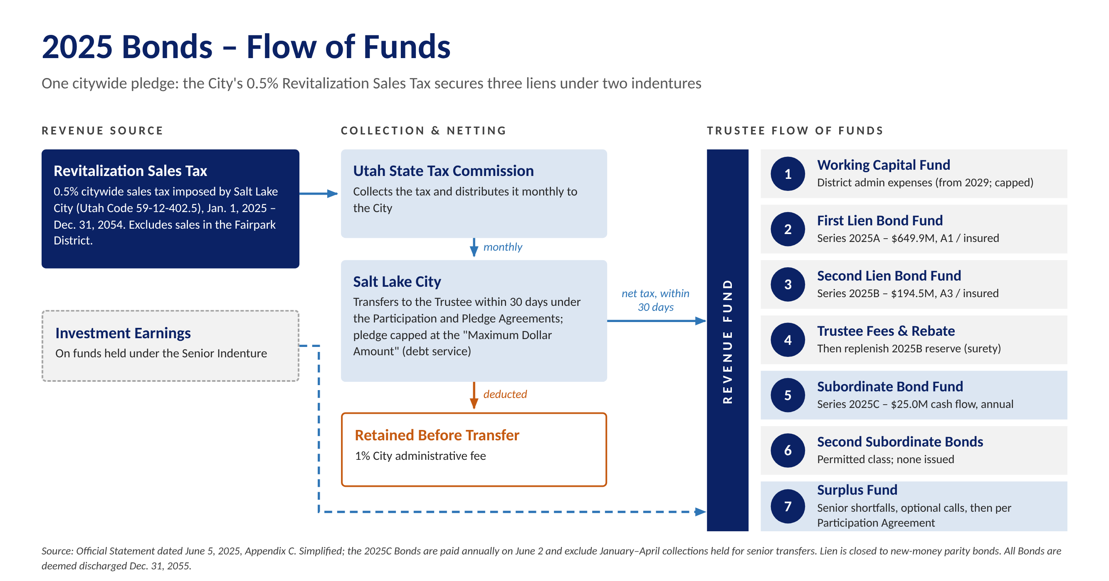
2025 Bonds flow of funds (simplified from the Official Statement by Tierra)
What This Means for the 2027 Bonds
- Fitting beside the 2025 liens. The 2025 first and second liens are closed to new money, and the indenture permits Second Subordinate Bonds only when no Subordinate Bonds are outstanding. The District's 2027 budget shows the remaining $19.5 million of 2025C Bonds paid down with cash; they are also callable at par from January 15, 2027, so refunding them as part of the Series 2027 issue is another possibility. The Series 2027 Bonds could take a junior lien position on the Revitalization Sales Tax together with a first lien on the new City and County revenues or sit under a separate indenture with the sales tax surplus as secondary support. Both must be tested with counsel against the Participation Agreement ($900 million cap and maximum dollar amount) and the statutory limits on the tax.
- Revenue Distribution. We would expect a new indenture for the Series 2027 Bonds that ties into the 2025 waterfall. The County's 4th quarter increment share and the City's 5th-5th increment share would go to the Series 2027 trustee with a first lien. The Revitalization Sales Tax would still pay the 2025A and 2025B Bonds first with the remainder going to the Series 2027 Bonds through the 2025 indenture's subordinate position. This only happens if the 2025C Bonds are no longer outstanding. The 2027 indenture would then pay 2027A, 2027B and 2027C debt service and fund a rate stabilization fund before any release (Figure 3 and Appendix B, Figure B-5).
- Interlocal agreements are the credit documents. Each must be irrevocable for the life of the bonds, define the revenue and its priority against the City's and County's other obligations, include non-impairment and additional bonds covenants, and route revenue directly to the trustee. The County must commit its 4th-quarter increment share for the full term, and the City's 5th-5th increment transfer must run for the bondable term; both depend on countywide taxes the County could change, which investors will scrutinize.
- Variability in rates. Rising rates have been a concern in past Board discussions. For perspective, each 50-basis point rise in rates reduces proceeds by about $45 million under a rising debt service structure. We would be happy to share more detailed funding and scenario analysis with the Board upon request.
- The County is a partner. The County owns the Salt Palace and will lead in its reconstruction; it is already budgeting for Salt Palace debt service and its own $150 million Visitor and Promotion Fund bonds.
Alternative Structures and Rating Implications
Structure | When It Fits | Rating / Market Implication
Combined pledge: junior lien on the Revitalization Sales Tax plus first lien on the County 4th quarter and City 5th-5th shares | After the 2025C Bonds are retired – paid down with cash, as the 2027 budget shows, or refunded into the Series 2027 issue | Broadest security; rating rests mainly on the new revenues; insurance possible as in 2025
Separate indenture on the County and City transportation-tax shares, with sales tax surplus as secondary support | If the 2025 documents limit junior liens, or a cleaner credit is preferred | Rated on the new revenues alone; simpler for investors to analyze
Phased issuance or draw-down placement | Draws extend over several years (Salt Palace closes fall 2027; completion targeted for 2031) | Reduces negative arbitrage and capitalized interest; later series priced on actual collections
Rating agencies will focus on the breadth of the countywide and City shares, the irrevocability of each pledge, coverage at maximum annual debt service and the additional bonds test. The task in 2027 is to earn strong ratings on the new revenues while keeping the 2025 liens and their coverage intact.
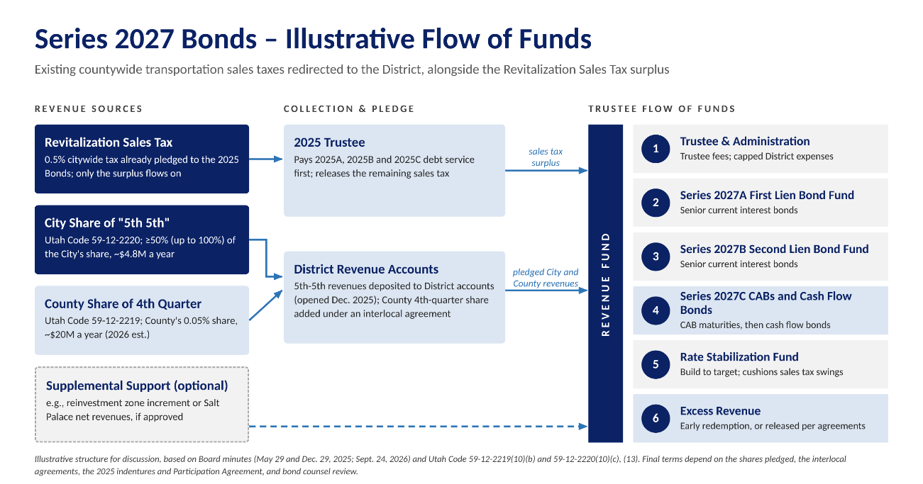
Tierra's Series 2027 Model
Tierra has built a proprietary cash flow model for the District that sets the 2025 bonds alongside a proposed 2027 financing. Using a combination of 2027A first lien and 2027B second lien current interest bonds plus subordinate 2027C bonds, the identified revenues (about $32 million in 2028, which is County share + City Share + Revitalization Tax Excess Transfer) support net proceeds of $680 million in our base case. Please see our proposed sources and uses table below. We also tested a downside case and a reduced growth case. In our downside case senior coverage holds at 1.00x and every bond is still paid; under our reduced growth case, senior coverage falls to about 0.66x. More detail on these scenarios is in Appendix B (Figures B-3 and B-4) and Appendix C. Tierra is ready to hit the ground running: our proprietary model is built and ready to test pledges, structures, rates and timing considerations for the District.
Illustrative Sources and Uses (Base Case) | Amount
Sources of Funds
Series 2027A First Lien Bonds | $422,245,000
Series 2027B Second Lien Bonds | 119,480,000
Series 2027C-1 Subordinate CABs (initial value) | 107,137,137
Series 2027C-2 Subordinate Cash Flow Bonds | 45,925,000
Total Sources | $694,787,137
Uses of Funds
Project Fund (Salt Palace and related improvements) | $680,000,000
Capitalized Interest (through June 1, 2030) | 5,903,492
Underwriter's Discount | 5,078,391
Costs of Issuance (including rounding) | 3,805,254
Total Uses | $694,787,137
Tierra estimate; 1.24x senior coverage; senior debt service of $25.8 million in 2028 rising to $44.8 million from 2038; CAB maturity value $427.1 million; 5.25% first lien and 5.50% second lien bonds, 6.50% CABs and 7.50% cash flow bonds, final maturity 2054; 100% of the County and City shares pledged; costs at Series 2025 rates; no reserve fund (assumed to be replaced with a surety policy upon the District being approved for bond insurance) or 2025C refunding.
Structuring Options Tested
We tested five structures in the model, each delivering $680 million of net construction proceeds. Option 1 mirrors the 2025 financing with senior bonds and cash flow bonds. In order to fund the full proceeds amount, the structure requires $241 million of cash flow bonds, more than the market is likely to absorb today, and $155 million would go unpaid in the downside case. Option 2 splits the subordinate bonds 70% to CABs and 30% cash flow bonds (trying to make a more marketable structure), cutting the unpaid amount to $25 million. Option 3 adds three years of capitalized interest, which supports $135 million more senior debt. At 1.15x, however, senior coverage falls to 0.93x in the downside case. Option 4 raises senior coverage to 1.24x, which holds 1.00x in the downside case. Option 5 delays the first CAB maturity to 2041, after senior debt service levels off, so every bond is paid in the downside case (Appendix B-3 and Appendix C).
Option | Structure (each adds to the one above) | Senior + Sub. / CABs / Cash Flow Bonds | Senior Coverage: Base / Downside | Downside Case Result
1 | All cash flow bonds; 1.25x senior; no CAPI | $448M / $0M / $241M | 1.25x / 1.01x | $155M of cash flow bonds unpaid at 2054
2 | Split 2027C 70% CABs / 30% cash flow bonds | $448M / $169M / $72M | 1.25x / 1.01x | $25M of CAB maturities unpaid
3 | Add 3 years of CAPI; 1.15x senior; ramp to 2038 | $583M / $78M / $34M | 1.15x / 0.93x | $21M of CAB maturities unpaid
4 | Raise senior coverage to 1.24x (1.00x in the downside) | $542M / $107M / $46M | 1.24x / 1.00x | $26M of CAB maturities unpaid
5 | Start CAB maturities in 2041 (recommended) | $542M / $107M / $46M | 1.24x / 1.00x | All paid; cash flow bonds repaid by 2053
Suggested Financing Plan and Timeline
Based on our preliminary analysis, Tierra would suggest Option 5 as the starting point: a single 2027 issue sized to the $680 million project fund, with $542 million of 2027A first lien and 2027B second lien current interest bonds – rated, and potentially insured as in 2025 – secured by the County 4th quarter and City 5th-5th increment shares and the Revitalization Sales Tax remaining after the 2025 Bonds. Senior debt service would rise with revenue through 2038 at 1.24x coverage, enough to hold 1.00x in a downside case, with three years of capitalized interest (through 2030) while the Salt Palace is under construction. About $153 million of unrated 2027C subordinate bonds would complete the financing: 70% CABs maturing from 2041 to 2054, after senior debt service levels off, and 30% cash flow bonds. We would refine the plan as the pledged shares, the lien position under the 2025 documents and the rating and insurance strategy are confirmed and consider phasing if the County's draw schedule favors it. An abbreviated proposed timeline is below.
Timing | Key Activities
Nov 2026 – Feb 2027 | Review the 2025 indentures, Participation Agreement and S.B. 26 for lien capacity; confirm the County 4th quarter and City 5th-5th shares to be pledged and their collection history; build an integrated model of the 2025 and Series 2027 credits; identify legal and tax questions for counsel.
Feb – May 2027 | Recommend security, lien structure, sizing, timing and method of sale; present options to the Board; negotiate interlocal pledge terms with the City, County and State.
Apr – Jul 2027 | Run underwriter selection; develop rating and insurance strategy; draft documents.
Second half 2027 | Rating presentations, investor outreach, pricing and closing of the first series ahead of the Salt Palace closure in fall 2027; evaluate later series against the County's draw schedule.

E. Team Serving the District
Evan Kist, CFA, will be the lead advisor. All Tierra advisors report directly to Mr. Kist. Detailed resumes are in Appendix A.
Team Member | Responsibilities | Experience and Education
Evan Kist, CFA  Managing Director & Principal  Lead Advisor  Series 50 & 54 | Overall strategy and credit structuring; cash flow and sizing models; negotiations with the City, County, State and underwriters; leads pricing; presents to the Board; supervises all work product and compliance. | Started Tierra in September 2019. More than 20 years in municipal finance, including 10 years at Merrill Lynch. BA Economics, University of New Mexico (Phi Beta Kappa); CFA charterholder.
Amanda Salome  Director  Day-to-Day Advisor  Series 50 | Document review, due diligence, POS/OS coordination, financing schedules, procurement of underwriters and other professionals, continuing disclosure support. | Joined Tierra in March 2025. More than 15 years in investment and commercial banking, including J.P. Morgan and Merrill Lynch. BA Economics and Geographical Studies, University of Chicago.
Chris Prugar  Managing Director  Day-to-Day Advisor  Series 50 | Rating agency and investor materials, numeric support and transaction execution. | Joined Tierra in April 2022. More than 16 years in public finance, including BofA Securities. BS Business Administration, Washington and Lee University (cum laude).

F. Utah Sales Tax and Tax Increment Transactions
Tierra's Utah sales tax and tax increment experience is described in our response to Section A. It includes Mr. Kist's work on the Utah Transit Authority's $50 million subordinate sales tax revenue bonds, our team's more than $2.5 billion of sales tax and tax increment experience (while at prior firms), our UIPA coverage, and our Colorado urban renewal and Texas TIRZ work. Our other relevant experience follows.
Colorado urban renewal authorities. In 2024, Tierra served as municipal advisor to St. Vrain Lakes Metropolitan District No. 2 (Firestone, Colorado) on a $58 million new money and refunding financing: $40.9 million of senior bonds and $17.7 million of subordinate cash flow bonds. About two-thirds of the district's assessed value lies in the Central Firestone Urban Renewal Area. The URA collects about $1.9 million of increment on the district's mills and reallocates it to the district through a cooperation agreement, and that revenue secures the bonds.
Hotel and Convention Center Experience. Tierra's professionals have sales tax and hotel occupancy tax revenue bond experience for the Louisiana Stadium and Exposition District (Superdome), the Metropolitan Pier and Exposition Authority in Illinois, and the Louisville Convention Center in Kentucky (KFC Yum! Arena). among others. They also have advised the Seminole Tribe of Florida on its Hard Rock hotels and casino assets. In total, Tierra's professionals have served as senior managing underwriter or municipal advisor on more than $2.0 billion of hotel and convention center financings.

G. Utah Tax Increment Transactions
Utah tax increment financing redirects some or all of the tax growth above a pre-development base to pay for the infrastructure that made the growth possible. Community reinvestment agencies collect most local increment under interlocal agreements with each taxing entity. State-created development authorities – UIPA, MIDA, The Point and UFAIR – capture "tax differential" under their own statutes and often pledge it by interlocal agreement to a subsidiary district's bonds, as UIPA did for its 2021 Crossroads PID bonds. The convention center reinvestment zone created by S.B. 26 (2025) extends the idea to sales tax. Whatever the source, the credit turns on how certain the increment is, how long it is pledged, what comes ahead of it and whether the agreements hold for the life of the bonds.
Tierra's experience applies directly. For development districts in Colorado, Texas and many other markets, we model increment – base year, growth, collection lags and term – layer it with district revenues, and stress-test it for slower growth and higher rates. We have negotiated the agreements behind these pledges, covering share and term, priority, non-impairment, additional-bonds protections and direct payment to the trustee. These are the terms the District will need with the City and County. We also know how rating agencies weigh these credits, and as an independent advisor we can help the District turn a multi-party increment pledge into a strongly rated 2027 bond financing.

H. Approach to the Scope of Work
Creative solutions driven by technical capabilities. Tierra's advisors work hard to solve their clients' most challenging financing situations. We build tailormade, dynamic cash flow and financing models to each client's needs and perform our own analysis rather than endorsing recommendations from underwriters or other parties, keeping our advice independent. Our recommendations are grounded in data-driven modeling, comprehensive market research and a clear understanding of the District's financial objectives.
Tierra will dedicate the entire resources of our firm to this assignment. Below are brief explanations of our planned approach to the Scope of Work items found in Section III of the proposal.
Section III Service | Tierra's Approach
A. Current debt and refunding | Monitor the 2025 Bonds against call dates (2025A 2036–2039 maturities June 1, 2030; later maturities and 2025B June 1, 2035; 2025C from January 15, 2027). Ensure any refunding proposal does not violate the 2025 Indenture and the restriction on refundings – debt service cannot increase in any year. Measure savings against each call's option value, not just a 3% present value test. Refundings can also restructure liens or covenants; tax-exempt refundings must be current (within 90 days of a call).
B. Future debt issues | Plan of finance for the 2027 bonds (Section D): security, liens, sizing, timing and method of sale, stress-tested for recession and higher rates.
C. Life-cycle cost | Compare all-in cost of each alternative, including issuance costs, insurance and surety premiums, capitalized interest (if necessary), negative arbitrage and reserve funding, in present value terms.
D. Documents | Work with bond and disclosure counsel and underwriters on the POS/OS, indentures and pledge agreements; coordinate printing and distribution.
E. Underwriting bids | Run a competitive selection; require a marketing book, pre-pricing calls and real-time order access (S&P’s Gameday platform); price against our own comparables; resist over-collateralization and inflated fees; favor buy-and-hold investors; hold underwriters to their indications. Target the 82 holders of the 2025 Bonds.
F. Legal review | Review all documents for consistency with the plan of finance, the Governing Document and the 2025 indentures.
G. Compliance | Support continuing disclosure filings, coordinate rebate on the $622 million 2025 construction fund and future proceeds, and track post-issuance compliance.
H. Market developments | Regular market updates on rates, investor demand for sales tax and increment credits, federal tax policy affecting tax-exempt bonds, and SEC and MSRB developments.
I. Meetings | Attend due diligence sessions and Board meetings as requested; provide "Bonds 101" sessions for Board members.
J. Credit ratings | In coordination with the financing team, develop rating and insurance strategy, prepare rating agency presentations and lead the rating process.

I. References
While Tierra specializes in development finance, we have a strong track record of working with nearly every type of municipal client including cities, counties, infrastructure, transportation, state-level agencies, utilities, tribal governments, hospitals, and special situation borrowers. At prior firms, the majority of our work was with “major public entities.”
Today, while major public entities are often involved within our development finance transactions, we do not actively serve them as municipal advisors and would feel uncomfortable asking for a reference. Instead, please find the following client references.
Client | Contact Person and Title | Contact Information
National Finance Authority | John Stoecker, Program Administrator | john@nfabonds.com  603-369-3886
Brookfield Residential Land  (global developer; controls development districts across the U.S.) | Matt Castillo, Director of Business Strategies | matt.castillo@brookfieldrp.com 512-539-3675
Huffines Enterprises, Inc.  (large land developer in Texas; controls development districts in Dallas-Fort Worth area) | Drew McLoughlin, Director of Finance | drew@heiinc.com  214-738-3683
As mentioned in our cover letter, Tierra is proud to have previous work experience or working relationships with many of the consultants involved in the District's 2025 financing including Gilmore & Bell (bond, disclosure and District counsel), Pinnacle Consulting Group (District accountant) and D.A. Davidson (co-managing underwriter).

J. Fee Schedule
Tierra offers the District two options: serving only as municipal advisor for the pricing certificate or providing full municipal advisory services. Both are flat fees per bond issue, payable only if the financing closes, and may be paid from bond proceeds.
 | Municipal Advisor – Pricing Certificate Only | Full Municipal Advisory Services
Flat fee per bond issue* | $50,000 | $100,000
Scope | Independent review of the underwriter's pricing against market comparables; real-time order monitoring on the day of pricing; delivery of the municipal advisor's pricing certificate at closing | All services in Section III of the RFP (Section H): plan of finance, structuring and cash flow modeling, document review, underwriter selection, rating and insurance strategy, pricing, the pricing certificate and closing
Series 2027 Bonds | One fee for the issue, including all series priced together (2027A, 2027B and 2027C) | One fee for the issue, including all series priced together (2027A, 2027B and 2027C)
Refunding bonds | $50,000 per issue | $100,000 per issue
Continuing disclosure assistance | Not included | No additional charge
Ongoing advisory services outside a financing (refunding monitoring, Board meetings, market updates) | Not included | No additional charge
Payment | Contingent on closing; payable from bond proceeds | Contingent on closing; payable from bond proceeds
Out-of-pocket expenses | None | None
*Assumes a $700 million financing. If the financing is smaller, Tierra is willing to negotiate a lower fee.

Appendix A – Resumes

Evan Kist, CFA, Managing Director and Principal, Tierra Financial Advisors
Primary Contact
Texas / Utah | Utah office: 4100 N. Horton Way, Suite 300, Lehi, UT 84048
Evan has over 20 years of municipal finance experience and currently manages Tierra's municipal advisory business and strategy. He is the firm's Principal and leads the firm's quantitative development, structuring and solution delivery for existing and new clients. He also directs supervisory procedures and legal, compliance and regulatory requirements for the organization.
Evan currently serves as municipal advisor to development districts in Utah, Colorado, Arizona and Texas. His special district clients in Utah include Viridian Farm Public Improvement District Nos. 1-3 (Salem City), Tava Highlands Public Improvement District Nos. 1–3 (Heber City). Additionally, he advises clients on projects throughout the State.
Prior to joining Tierra in August 2019, Evan worked for RBC Capital Markets, where he served a large portfolio of clients as either a municipal advisor or senior managing underwriter. In both roles his clients included cities, counties, state-level agencies, regional water authorities, transportation systems, development districts, tribal governments and school districts.
Evan spent 10 years working for Merrill Lynch (now BofA Securities) in their New York and Chicago offices covering municipal issuers throughout the country, including power and energy, transportation, water, infrastructure, hospital systems, and special situation borrowers. He worked on 50+ senior managed public finance transactions totaling $8 billion, for clients such as New York City, Texas Department of Transportation, Dallas Area Rapid Transit, CPS Energy, State Revolving Funds (ND, IN), Jefferson County, AL (special advisor to the County during bankruptcy) and Parkland Hospital.
Evan graduated Phi Beta Kappa with a degree in Economics and minor in Finance from the University of New Mexico and is a Chartered Financial Analyst ("CFA") charterholder. He is an SEC registered municipal advisor holding the Series 50 and 54 licenses.

Chris Prugar, Managing Director, Tierra Financial Advisors
Day-to-Day / Backup Contact
Houston, Texas
Chris has over 16 years of public finance experience and has served in a wide variety of roles structuring, executing, and managing municipal bond transactions. Chris joined Tierra in April 2022 and serves as municipal advisor to many special districts located in Texas, and also supports Tierra's municipal advisory efforts in Colorado, Utah and Arizona.
Prior to joining Tierra, Chris worked for BofA Securities where he sourced negotiated bond transactions for special districts, water and sewer authorities, cities, counties, school districts, and special projects. His experience includes detailed cash flow modeling, client presentations, rating agency presentations, interfacing with the sales desk and transaction execution. Chris has been involved in over $20 billion of transactions, including Texas Municipal Gas Supply and Acquisition Corporation III (gas prepays), Unemployment Trust Fund financings, Texas Private Activity Bond Surface Transportation Corporation, Louisville Arena Authority, Louisiana Stadium and Exposition District (Superdome) and the City of Houston Airport System.
Chris graduated cum laude from Washington and Lee University with a Bachelor of Science in Business Administration. He is an SEC registered municipal advisor holding the Series 50 license.

Amanda Salome, Director, Tierra Financial Advisors
Day-to-Day / Backup Contact
Austin, Texas
Amanda brings over 15 years of investment and commercial banking experience to her role as Director at Tierra. She leads financial structuring, analytics, strategic planning, and continuing disclosure efforts for the team. She currently serves as municipal advisor to many special districts across Texas, and supports Tierra's municipal advisory efforts in Colorado, Utah and Arizona.
Prior to joining Tierra, Amanda served as Executive Director at J.P. Morgan Chase, managing a portfolio of 40 healthcare, higher education, and nonprofit clients across the Southern region, and was a key member of J.P. Morgan's national DBC Analytics Team. Earlier in her career, Amanda spent over a decade at Merrill Lynch (now BofA Securities), where she helped lead over 70 bond transactions totaling more than $9 billion in par value across 20 states. Most notably, Amanda served as the lead analyst and quantitative resource on the $1.8 billion formation financing of Providence St. Joseph Health System, structuring nine simultaneous bond series to refund and consolidate 17 existing series of debt across two legacy health systems.
Amanda holds a BA in Economics and Geographical Studies from the University of Chicago. She is an SEC registered municipal advisor holding the Series 50 license.

Appendix B – Credit Data and Charts
The charts in this appendix come from Tierra's own analysis of the District's Series 2025 bond financing. We built out the Series 2025 structure to compare how its performance against its original projections-and to apply our understanding of the existing Series 2025 bond structure to deepen our knowledge of how to model and test a proposed Series 2027 financing. In the following tables, charts and graphics we have highlighted the information we view as most important not only to the outstanding bonds, but to the future structure of the 2027 bonds. The following paragraph briefly describes each figure.
Figures B-1 and B-2 show how the 2025 Bonds are performing: projected coverage under each Official Statement case, and actual Revitalization Sales Tax collections against those projections. Collections are running ahead of the base case, which supports the junior-lien capacity available to the Series 2027 Bonds. Figures B-3 through B-6 show what that capacity means for 2027: Figure B-3 compares the five structures Tierra tested for a $680 million project fund and how each holds up in the downside case; Figure B-4 shows the recommended structure year-by-year against base and downside pledged revenue; and Figures B-5 and B-6 show how revenue would flow and how the 2027 Bonds would layer beside the 2025 liens. Separately, Figure B-7 identifies the investors that already own District bonds, making them the natural first audience for investor outreach on a 2027 bond issue.
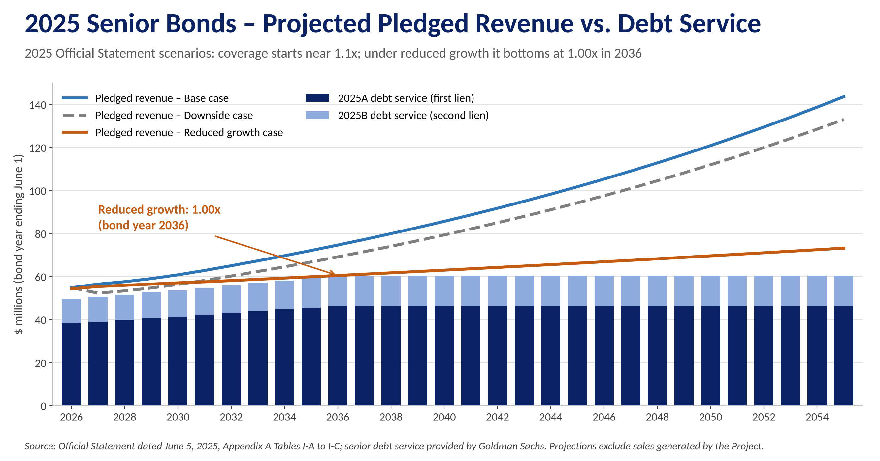
Figure B-1: 2025 Senior Bonds – projected pledged revenue versus debt service under the three Official Statement scenarios
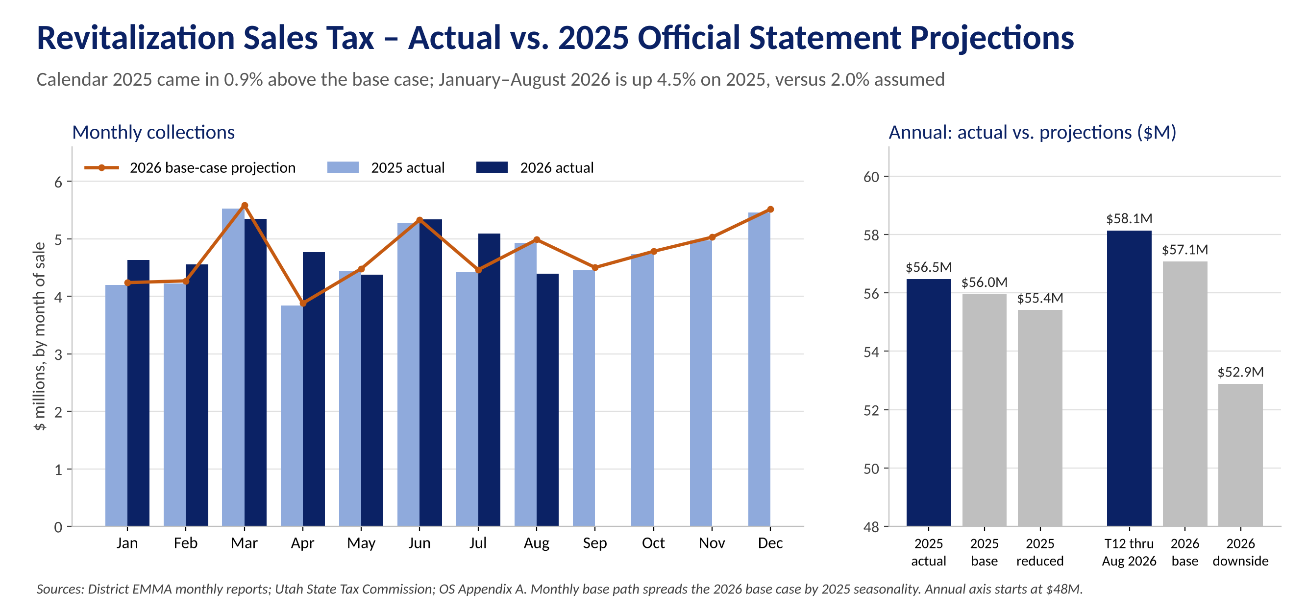
Figure B-2: Revitalization Sales Tax – actual collections vs. 2025 Official Statement projections
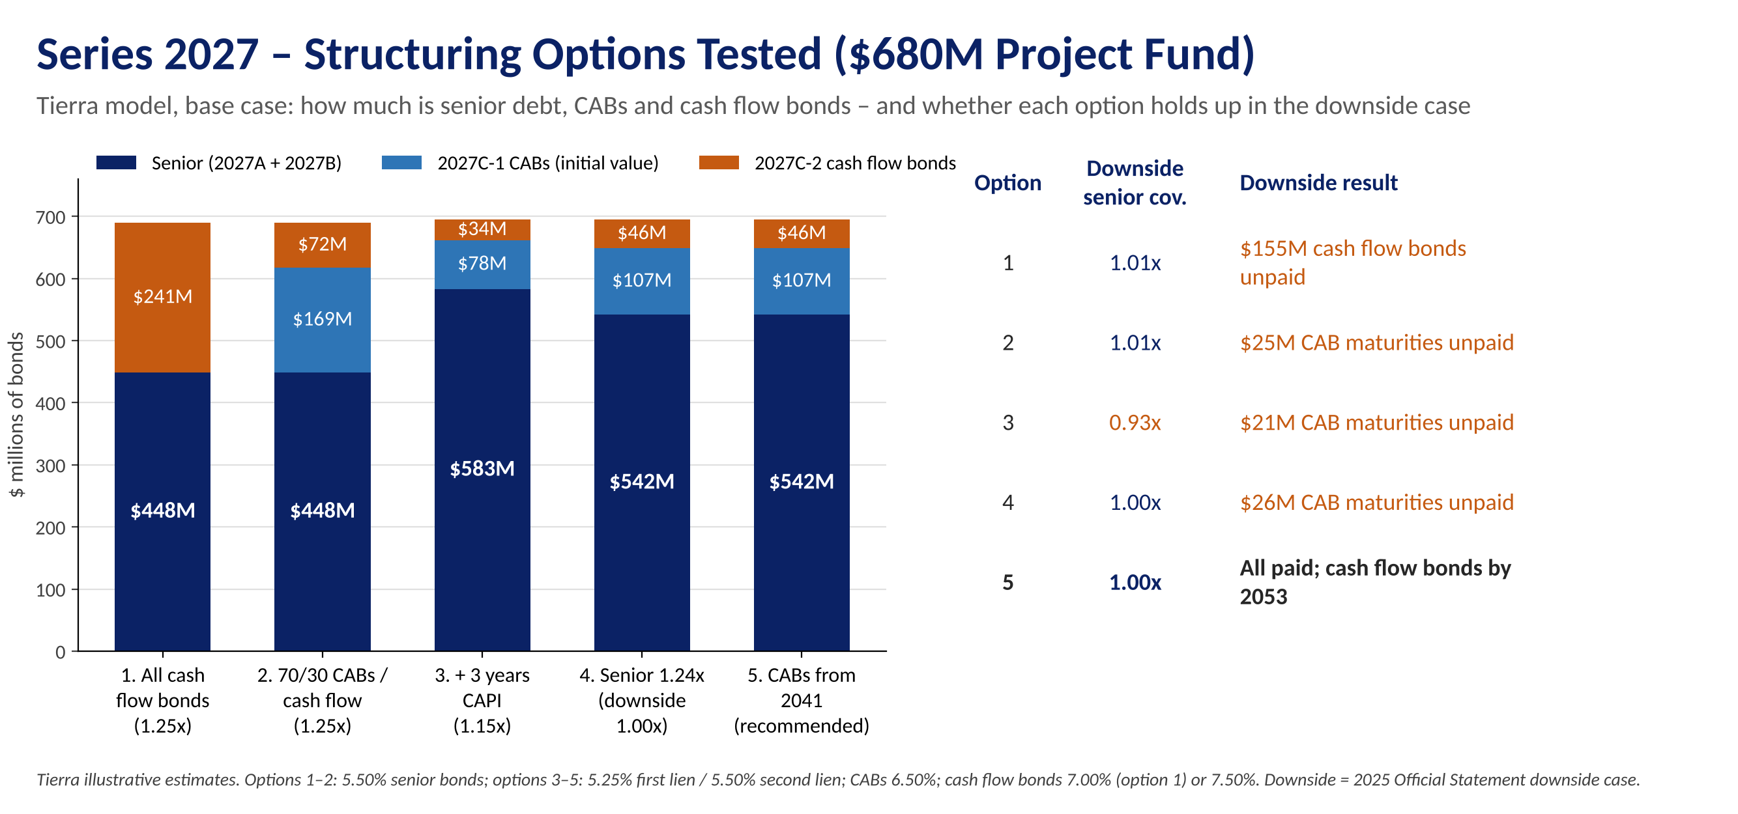
Figure B-3: Series 2027 – structuring options tested for a $680 million project fund
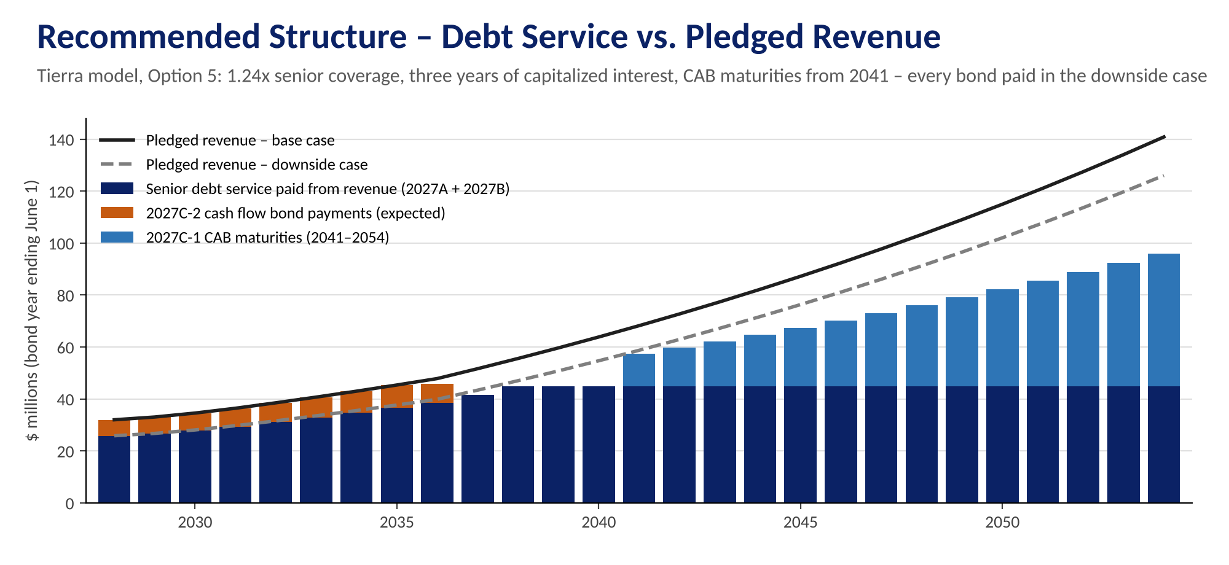
Figure B-4: Recommended structure – debt service versus base and downside pledged revenue
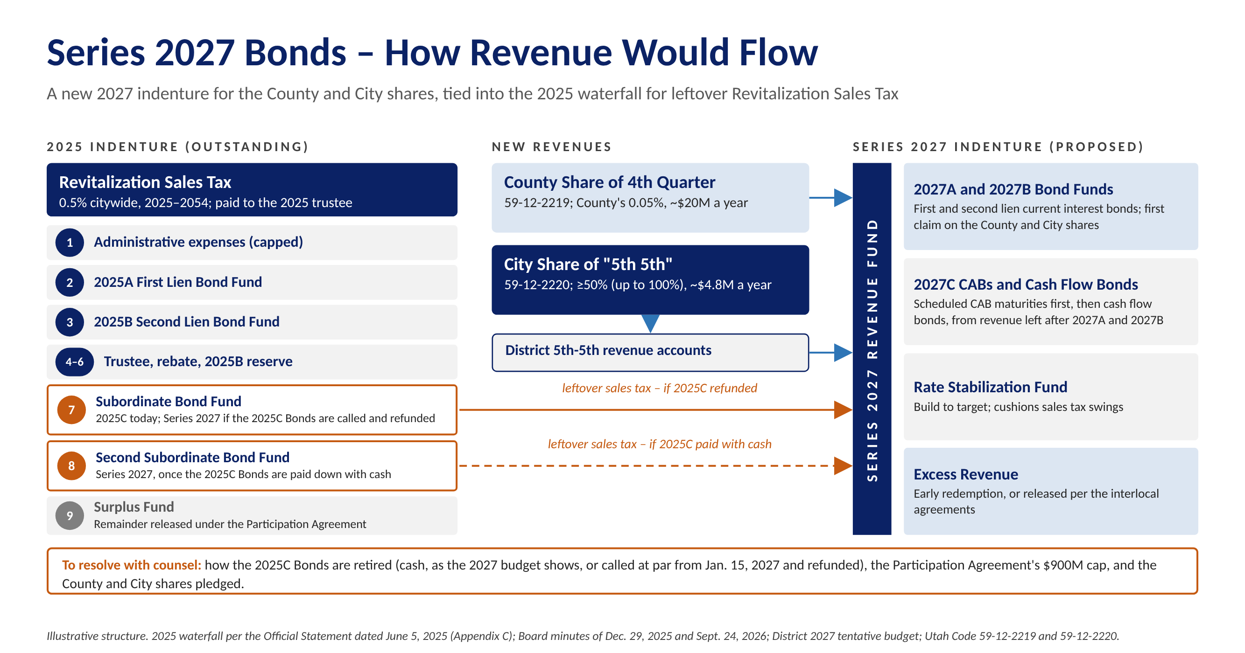
Figure B-5: Series 2027 Bonds – illustrative chart of how revenue would flow
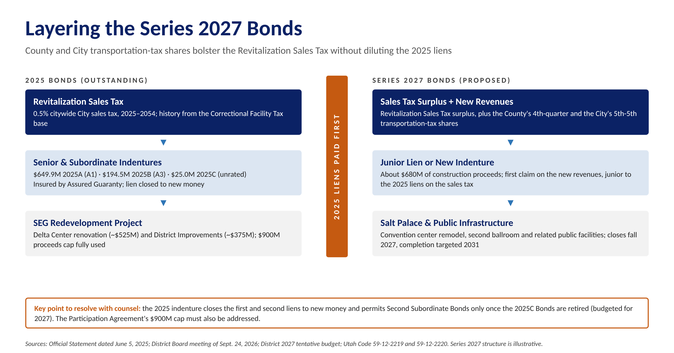
Figure B-6: Layering the Series 2027 Bonds beside the 2025 liens
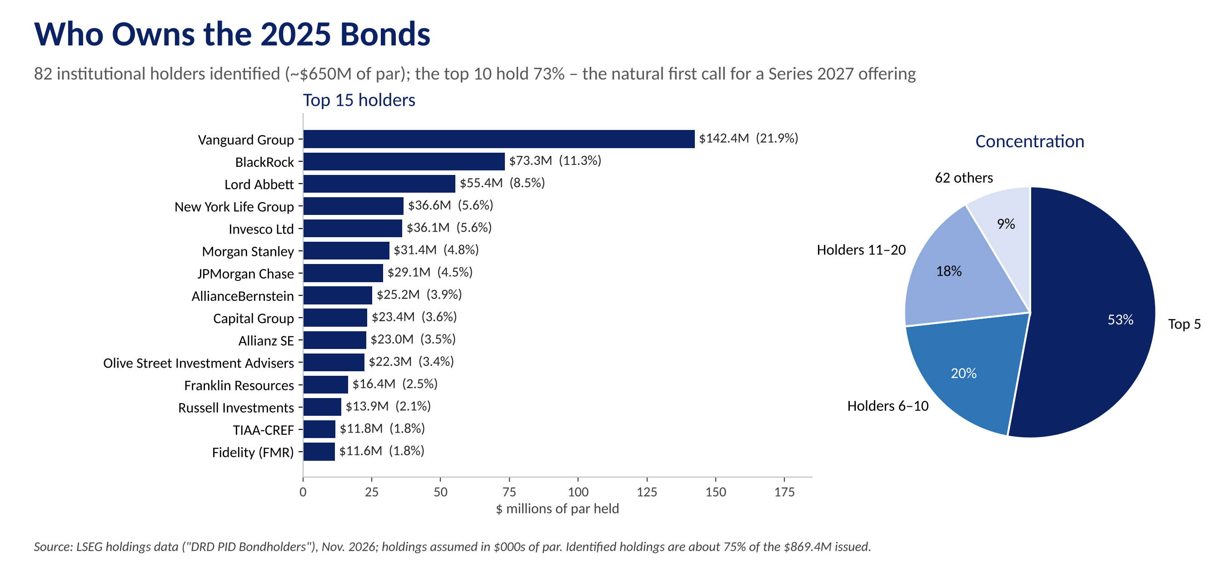
Figure B-7: Who Owns the Series 2025 Bonds - Institutional Holders

Appendix C – Series 2027 Preliminary Cash Flows
Below and on the following page is a snapshot of Tierra's proprietary cash flow model for the District: a $680 million project fund financed with Series 2027A first lien and 2027B second lien current interest bonds and subordinate 2027C bonds. The first page summarizes sources and uses, bond statistics, the series structure, how the structure holds up under each revenue case, and the sizing assumptions. The second page shows debt service, pledged revenue, coverage, CAB maturities and expected cash flow bond payments by bond year. We include it to show the District the kind of independent analysis Tierra can provide the Board before it sets the size, structure or timing of the Series 2027 Bonds. Our model is dynamic where revenue pledges, coverage, rates, timing and the target project fund can all be changed with the Board and the financing team.
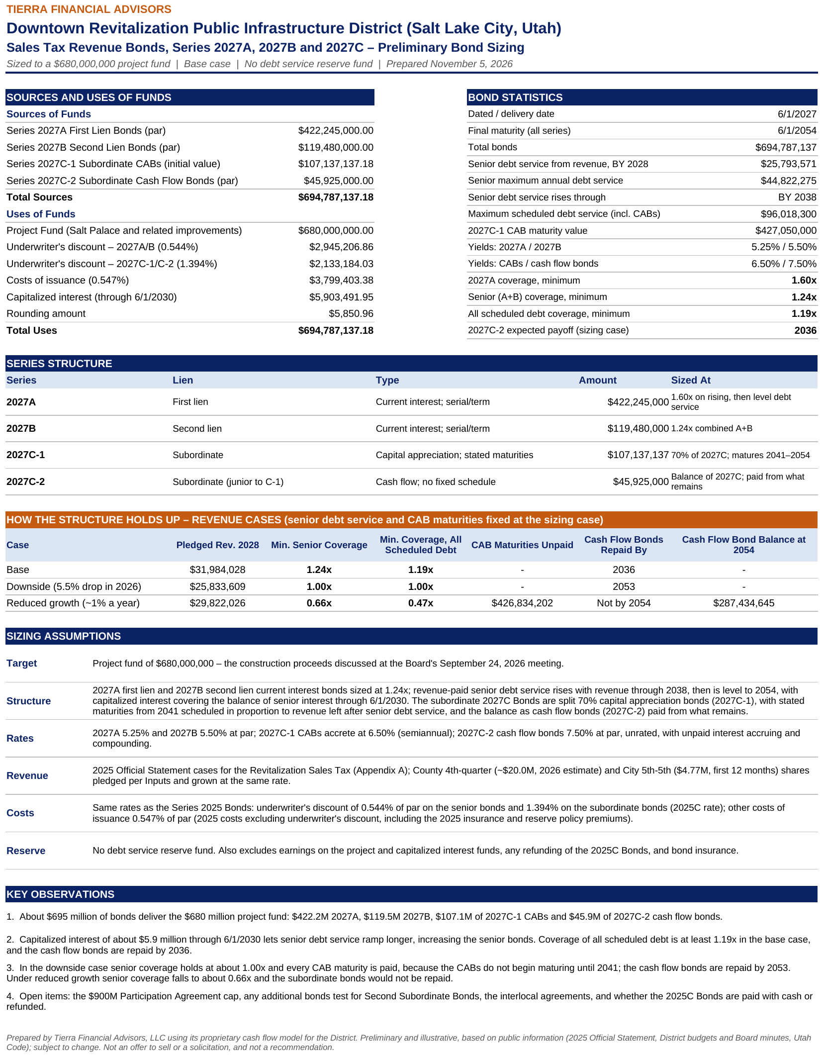
Figure C-1: Series 2027 preliminary bond sizing – summary (base case)
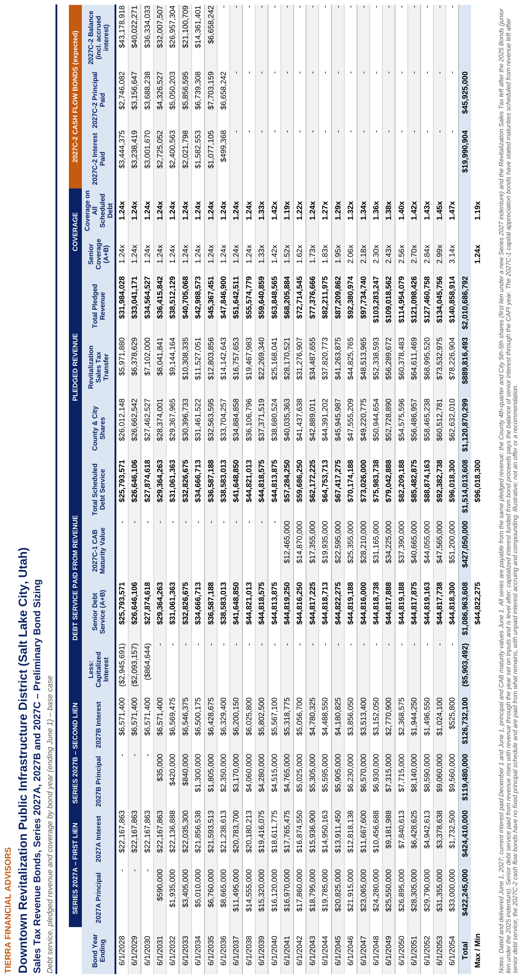
Figure C-2: Series 2027 debt service, pledged revenue and coverage by bond year (base case)

Structuring Options Tested
Before settling on the structure in Figures C-1 and C-2, Tierra tested five structures in the same model, each delivering a $680 million project fund. Each option builds on the one before it:
- Option 1 – senior bonds plus cash flow bonds. Mirrors the 2025 approach. Senior capacity is limited because first-year revenue must cover interest on the senior bonds, leaving about $241 million of subordinate cash flow bonds which is a large amount of unrated paper and not likely marketable in today’s environment. $155 million of 2027C bonds go unpaid in the downside case.
- Option 2 – split the subordinate bonds. Issuing 70% of the subordinate bonds as CABs with stated maturities cuts the cash flow bonds to about $72 million, but CAB maturities scheduled from 2028 go partly unpaid in the downside case, when little revenue is left after senior debt service.
- Option 3 – capitalized interest. Three years of capitalized interest (through June 1, 2030) lets senior debt service rise with revenue through 2038, increasing the senior bonds to about $583 million at 1.15x – but senior coverage falls to 0.93x in the downside case.
- Option 4 – protect the senior bonds. Sizing the senior bonds at 1.24x holds senior coverage at 1.00x in the downside case; CAB maturities in the early years still fall short.
- Option 5 – recommended. Starting the CAB maturities in 2041, after senior debt service levels off, directing early surplus to the cash flow bonds and leaving every CAB maturity and cash flow bond paid in the downside case. The trade-off is longer-dated CABs, which may price above the assumed 6.50% rate.
- All Options Under the reduced-growth case (about 1% a year), no structure supported by these revenues keeps the senior bonds above 1.00x – the same is true of the 2025 senior bonds, which fall to 1.00x in that case.
Measure | Option 1 | Option 2 | Option 3 | Option 4 | Option 5
Senior coverage target | 1.25x | 1.25x | 1.15x | 1.24x | 1.24x
Capitalized interest | – | – | $6M | $6M | $6M
CAB share / first CAB maturity | – | 70% / 2028 | 70% / 2028 | 70% / 2028 | 70% / 2041
2027A first lien | $350M | $350M | $422M | $422M | $422M
2027B second lien | $98M | $98M | $161M | $119M | $119M
2027C-1 CABs (initial value) | – | $169M | $78M | $107M | $107M
2027C-1 CAB maturity value | – | $555M | $274M | $359M | $427M
2027C-2 cash flow bonds | $241M | $72M | $34M | $46M | $46M
Total bonds | $690M | $690M | $695M | $695M | $695M
Base: min. senior coverage | 1.25x | 1.25x | 1.15x | 1.24x | 1.24x
Base: min. coverage, all scheduled debt | 1.25x | 1.11x | 1.10x | 1.13x | 1.19x
Base: cash flow bonds repaid by | 2050 | 2044 | 2041 | 2041 | 2036
Downside: min. senior coverage | 1.01x | 1.01x | 0.93x | 1.00x | 1.00x
Downside: CAB maturities unpaid | – | $25M | $21M | $26M | –
Downside: cash flow bonds repaid by | Not by 2054 | Not by 2054 | 2049 | 2051 | 2053
Downside: cash flow bonds unpaid at 2054 | $155M | $23M | – | – | –
Reduced growth: min. senior coverage | 0.80x | 0.80x | 0.61x | 0.66x | 0.66x
Tierra illustrative estimates. Options 1–2: 5.50% senior bonds; options 3–5: 5.25% first lien and 5.50% second lien bonds. CABs 6.50%; cash flow bonds 7.00% (option 1) or 7.50%. Costs at Series 2025 rates; no reserve fund. Downside and reduced-growth cases from the 2025 Official Statement.

Stress Test – How the Structure Holds Up Under Each Revenue Case
Senior debt service and CAB maturities are held at the base-case sizing while pledged revenue follows each case. Coverage is shown on all scheduled debt (senior bonds plus CAB maturities). Any CAB maturity that revenue cannot cover is shown as a shortfall; the cash flow bonds are paid from what remains, and their balance (including accrued and, compounding interest) shows how quickly they are repaid. Figures in $ millions.
Bond Year | Base: Pledged Rev. | Base: Sched. Cov. | Base: CAB Short | Base: CFB Bal. | Down: Pledged Rev. | Down: Sched. Cov. | Down: CAB Short | Down: CFB Bal. | Reduced: Pledged Rev. | Reduced: Sched. Cov. | Reduced: CAB Short | Reduced: CFB Bal.
2028 | 31.98 | 1.24x | - | 43.18 | 25.83 | 1.00x | - | 49.58 | 29.82 | 1.16x | - | 45.34
2029 | 33.04 | 1.24x | - | 40.02 | 26.74 | 1.00x | - | 53.46 | 29.61 | 1.11x | - | 45.81
2030 | 34.56 | 1.24x | - | 36.33 | 28.07 | 1.01x | - | 57.52 | 29.39 | 1.05x | - | 47.87
2031 | 36.42 | 1.24x | - | 32.01 | 29.70 | 1.01x | - | 61.74 | 28.99 | 0.99x | - | 51.71
2032 | 38.51 | 1.24x | - | 26.96 | 31.56 | 1.02x | - | 66.09 | 28.74 | 0.93x | - | 55.85
2033 | 40.71 | 1.24x | - | 21.10 | 33.51 | 1.02x | - | 70.58 | 28.48 | 0.87x | - | 60.29
2034 | 42.99 | 1.24x | - | 14.36 | 35.54 | 1.03x | - | 75.20 | 28.20 | 0.81x | - | 65.07
2035 | 45.37 | 1.24x | - | 6.66 | 37.66 | 1.03x | - | 79.94 | 27.91 | 0.76x | - | 70.20
2036 | 47.85 | 1.24x | - | - | 39.86 | 1.03x | - | 84.82 | 27.60 | 0.72x | - | 75.72
2037 | 51.64 | 1.24x | - | - | 43.38 | 1.04x | - | 89.58 | 28.49 | 0.68x | - | 81.66
2038 | 55.57 | 1.24x | - | - | 47.02 | 1.05x | - | 94.19 | 29.39 | 0.66x | - | 88.03
2039 | 59.64 | 1.33x | - | - | 50.79 | 1.13x | - | 95.09 | 30.29 | 0.68x | - | 94.89
2040 | 63.85 | 1.42x | - | - | 54.69 | 1.22x | - | 91.86 | 31.21 | 0.70x | - | 102.26
2041 | 68.21 | 1.19x | - | - | 58.73 | 1.03x | - | 97.46 | 32.13 | 0.56x | 12.46 | 110.19
2042 | 72.71 | 1.22x | - | - | 62.90 | 1.05x | - | 101.57 | 33.07 | 0.55x | 14.87 | 118.71
2043 | 77.38 | 1.24x | - | - | 67.22 | 1.08x | - | 104.02 | 34.01 | 0.55x | 17.36 | 127.87
2044 | 82.21 | 1.27x | - | - | 71.70 | 1.11x | - | 104.61 | 34.96 | 0.54x | 19.93 | 137.71
2045 | 87.21 | 1.29x | - | - | 76.33 | 1.13x | - | 103.13 | 35.92 | 0.53x | 22.59 | 148.29
2046 | 92.38 | 1.32x | - | - | 81.12 | 1.16x | - | 99.36 | 36.89 | 0.53x | 25.36 | 159.67
2047 | 97.73 | 1.34x | - | - | 86.08 | 1.18x | - | 93.03 | 37.87 | 0.52x | 28.21 | 171.90
2048 | 103.28 | 1.36x | - | - | 91.22 | 1.20x | - | 83.89 | 38.87 | 0.51x | 31.16 | 185.05
2049 | 109.02 | 1.38x | - | - | 96.54 | 1.22x | - | 71.63 | 39.87 | 0.50x | 34.23 | 199.18
2050 | 114.95 | 1.40x | - | - | 102.03 | 1.24x | - | 55.95 | 40.88 | 0.50x | 37.39 | 214.38
2051 | 121.10 | 1.42x | - | - | 107.73 | 1.26x | - | 37.15 | 41.90 | 0.49x | 40.66 | 230.71
2052 | 127.46 | 1.43x | - | - | 113.62 | 1.28x | - | 15.19 | 42.94 | 0.48x | 44.05 | 248.27
2053 | 134.05 | 1.45x | - | - | 119.72 | 1.30x | - | - | 43.98 | 0.48x | 47.56 | 267.14
2054 | 140.86 | 1.47x | - | - | 126.03 | 1.31x | - | - | 45.03 | 0.47x | 50.98 | 287.43
Source: Tierra Series 2027 Sizing Model. Base, downside and reduced-growth cases from the 2025 Official Statement, with the County and City shares grown at the same rate as the Revitalization Sales Tax in each case. Under reduced growth, senior coverage falls below 1.00x, CAB maturities go largely unpaid and the cash flow bonds are not repaid.

Appendix D – Bond Issues Advised Since September 2021
The following is a complete list of the municipal bond issues on which Tierra served as municipal advisor or structuring advisor over the past five years: 122 transactions totaling $1.65 billion, everyone for a development project, across Texas, Colorado and Utah.
Delivery | Issuer | State | Series | Par Amount ($) | Tierra Role | Underlying (Moody's / S&P) | Insured (Moody's / S&P)
12/08/26 | Waller Co MUD #47 | TX | U/L Tax Road Bds Ser 2026 | 2,000,000 | Municipal | NR | –
11/10/26 | Huffines DFW Projects | TX | Special Rev Bds Ser 2026 | 66,496,971 | Structuring | NR | –
09/30/26 | Beazer Pooled Project | TX | Special Rev Bds Ser 2026 | 73,140,000 | Structuring | NR | –
09/30/26 | Viridian Farm PID #1 | UT | Ltd Tax Bds Ser 2026A | 7,180,000 | Municipal | NR | –
09/30/26 | Viridian Farm PID #1 | UT | Sub Ltd Bds 2026B | 1,410,000 | Municipal | NR | –
09/29/26 | Silver Peaks Metro District No. 6 | CO | Ltd Tax Bds Ser 2026A | 7,500,000 | Municipal | NR | –
09/29/26 | Silver Peaks Metro District No. 6 | CO | Sub Ltd Bds 2026B | 1,980,000 | Municipal | NR | –
09/28/26 | Montgomery Co MUD #202A | TX | U/L Tax Road Bds Ser 2026 | 5,000,000 | Municipal | NR | NR / AA
09/10/26 | Fort Bend MUD No #222 | TX | U/L Tax Util Bds Ser 2026 | 20,000,000 | Municipal | NR | NR / AA
09/10/26 | Brazoria Co MUD #87 | TX | U/L Tax Road Bds Ser 2026 | 3,000,000 | Municipal | NR | NR / AA
08/27/26 | Fort Bend Co MUD #232 | TX | U/L Tax Util Bds Ser 2026 | 7,500,000 | Municipal | NR | NR / AA
08/24/26 | Ellis Co MUD #1B | TX | U/L Tax Util Bds Ser 2026 | 4,090,000 | Municipal | NR | NR / AA
08/20/26 | Fort Bend Co MUD #246 | TX | U/L Tax Util Bds Ser 2026 | 10,000,000 | Municipal | NR | NR / AA
08/20/26 | Legends Ranch MUD | TX | U/L Tax Road Bds Ser 2026 | 4,210,000 | Municipal | NR | NR / AA
08/20/26 | Legends Ranch MUD | TX | U/L Tax Util Bds Ser 2026 | 7,950,000 | Municipal | NR | NR / AA
08/19/26 | Brazoria Co MUD #81 | TX | U/L Tax Road Bds Ser 2026 | 3,000,000 | Municipal | NR | NR / AA
08/12/26 | Montgomery Co MUD #139 | TX | U/L Tax Util Bds Ser 2026 | 3,000,000 | Municipal | Baa1 / NR | NR / AA
08/10/26 | Dallas Co MUD #4 | TX | U/L Tax Road Bds Ser 2026 | 3,265,000 | Municipal | NR | NR / AA
08/10/26 | Dallas Co MUD #4 | TX | U/L Tax Util Bds Ser 2026 | 5,870,000 | Municipal | NR | NR / AA
07/16/26 | Brazoria-Fort Bend Counties MUD #3 | TX | U/L Tax Road Bds Ser 2026 | 5,000,000 | Municipal | Baa3 / NR | NR / AA
07/15/26 | East Hays Co MUD #1 | TX | U/L Tax Util Bds Ser 2026 | 6,000,000 | Municipal | NR | NR / AA
07/15/26 | Collin Co MUD #4 | TX | U/L Tax Util Bds Ser 2026 | 11,570,000 | Municipal | Baa3 / NR | A1 / AA
07/15/26 | Collin Co MUD #4 | TX | U/L Tax Road Bds Ser 2026 | 2,320,000 | Municipal | Baa3 / NR | A1 / AA
07/15/26 | Riverfield MUD #1 | TX | U/L Tax Util Bds Ser 2026 | 2,125,000 | Municipal | NR | NR / AA
07/15/26 | Fort Bend Co MUD #188 | TX | U/L Tax Road Bds Ser 2026 | 5,000,000 | Municipal | NR | NR / AA
06/30/26 | Lakeside Bayou Project | TX | Special Rev Bds Ser 2026 | 21,345,792 | Structuring | NR | –
04/16/26 | HistoryMaker/Empire Projects | TX | Special Rev Bds Ser 2026 | 31,630,000 | Structuring | NR | –
03/30/26 | Forestar Group Houston-Area Projects | TX | Special Rev Bds Ser 2026 | 153,000,000 | Structuring | NR | –
03/24/26 | Montgomery Co MUD #199 | TX | U/L Tax Road Bds Ser 2026 | 9,650,000 | Municipal | NR | –
12/23/25 | Katy Court Project - Development I | TX | Special Rev Bds Ser 2026 | 11,904,000 | Structuring | NR | –
12/23/25 | Katy Court Project - Development II | TX | Special Rev Bds Ser 2026 | 6,773,000 | Structuring | NR | –
12/23/25 | Katy Court Project - Development III | TX | Special Rev Bds Ser 2026 | 6,753,000 | Structuring | NR | –
12/09/25 | Ellston Park Metro District | CO | Ltd Tax Bds Ser 2025A | 2,235,000 | Municipal | NR | –
12/09/25 | Ellston Park Metro District | CO | Sub Ltd Bds 2025B | 295,000 | Municipal | NR | –
09/23/25 | East Montgomery Co MUD #14 | TX | U/L Tax Util Bds Ser 2025 | 4,000,000 | Municipal | NR | NR / AA
09/23/25 | Fort Bend Co MUD #232 | TX | U/L Tax Util Bds Ser 2025 | 5,400,000 | Municipal | NR | NR / AA
09/18/25 | Fort Bend Co MUD #246 | TX | U/L Tax Util Bds Ser 2025 | 5,200,000 | Municipal | NR | NR / AA
09/10/25 | Austin Co MUD #1 | TX | U/L Tax Road Bds Ser 2025 | 5,000,000 | Municipal | NR | –
08/26/25 | East Hays Co MUD #1 | TX | U/L Tax Util Bds Ser 2025 | 6,080,000 | Municipal | NR | NR / AA
08/26/25 | East Hays Co MUD #1 | TX | U/L Tax Road Bds Ser 2025 | 3,440,000 | Municipal | NR | NR / AA
08/19/25 | Brazoria-Fort Bend Counties MUD #3 | TX | U/L Tax Util Bds Ser 2025 | 8,000,000 | Municipal | Baa3 / NR | NR / AA
08/19/25 | Brazoria-Fort Bend Counties MUD #3 | TX | U/L Tax Road Bds Ser 2025 | 6,500,000 | Municipal | Baa3 / NR | NR / AA
08/14/25 | Collin Co MUD CR 412 | TX | U/L Tax Util Bds Ser 2025 | 5,200,000 | Municipal | NR | NR / AA
08/12/25 | Montgomery Co MUD #139 | TX | U/L Tax Util Bds Ser 2025 | 3,885,000 | Municipal | Baa1 / NR | NR / AA
08/12/25 | Montgomery Co MUD #139 | TX | U/L Tax Road Bds Ser 2025 | 2,815,000 | Municipal | Baa1 / NR | NR / AA
08/12/25 | Fort Bend Co MUD #222 | TX | U/L Tax Util Bds Ser 2025 | 25,000,000 | Municipal | NR | NR / AA
08/11/25 | Dallas Co MUD #4 | TX | U/L Tax Util Bds Ser 2025 | 6,865,000 | Municipal | NR | NR / AA
08/11/25 | Dallas Co MUD #4 | TX | U/L Tax Road Bds Ser 2025 | 3,780,000 | Municipal | NR | NR / AA
08/06/25 | Grand Pines Project | TX | Special Rev Bds Ser 2025 | 27,273,000 | Structuring | NR | –
08/06/25 | Magnolia Pointe MUD #1 | TX | U/L Tax Util Bds Ser 2025 | 2,525,000 | Municipal | Baa2 / NR | NR / AA
08/06/25 | Magnolia Pointe MUD #1 | TX | U/L Tax Road Bds Ser 2025 | 3,275,000 | Municipal | Baa2 / NR | NR / AA
07/09/25 | Riverfield MUD #1 | TX | U/L Tax Road Bds Ser 2025 | 4,120,000 | Municipal | NR | NR / AA
07/09/25 | Riverfield MUD #1 | TX | U/L Tax Util Bds Ser 2025 | 5,980,000 | Municipal | NR | NR / AA
07/09/25 | Collin Co MUD #4 | TX | U/L Tax Road Bds Ser 2025 | 6,270,000 | Municipal | Baa3 / NR | A1 / AA
07/09/25 | Collin Co MUD #4 | TX | U/L Tax Util Bds Ser 2025 | 8,630,000 | Municipal | Baa3 / NR | A1 / AA
06/26/25 | Mill Creek Project | TX | Special Rev Bds Ser 2025 | 26,685,000 | Structuring | NR | –
05/29/25 | Mirador Project | TX | Special Rev Bds Ser 2025 | 36,550,000 | Municipal | NR | –
05/28/25 | Timberleaf Metro District | CO | U/L Tax Ref Bds Ser 2025A | 9,895,000 | Municipal | NR | NR / AA
05/28/25 | Timberleaf Metro District | CO | Ltd Tax Bds Ser 2025B | 1,850,000 | Municipal | NR | –
05/15/25 | Fort Bend Co MUD #188 | TX | U/L Tax Util Bds Ser 2025 | 15,000,000 | Municipal | NR | NR / AA
04/24/25 | Princeton Area Projects | TX | Limited Tax Bds Ser 2025 | 52,830,000 | Structuring | NR | –
04/15/25 | Ellis Co MUD #1B | TX | U/L Tax Util Bds Ser 2025 | 4,700,000 | Municipal | NR | –
03/19/25 | Lackland Projects | TX | Special Rev Bds Ser 2025 | 85,566,271 | Municipal | NR | –
02/27/25 | Four Corners BID | CO | Sub Ltd Tax Rev Bds Ser 2025B | 1,875,000 | Municipal | NR | –
11/26/24 | St. Vrain Lakes MUD #2 | CO | Ltd Tax Ref Bds Ser 2024A | 40,855,000 | Municipal | NR / BBB | NR / AA
11/26/24 | St. Vrain Lakes MUD #2 | CO | Sub Ltd Tax Ref Bds Ser 2024B | 17,700,000 | Municipal | NR | –
11/13/24 | Easton Park Project (Districts 2 and 5) | TX | Limited Tax Bds Ser 2024 | 45,430,000 | Municipal | NR | –
11/06/24 | Silverado Project | TX | Special Rev Bds Ser 2024 | 47,300,000 | Structuring | NR | –
10/23/24 | Poetry Road MUD | TX | U/L Tax Util Bds Ser 2024 | 4,010,000 | Municipal | NR | –
09/27/24 | Dallas Co MUD #4 | TX | U/L Tax Util Bds Ser 2024 | 5,730,000 | Municipal | NR | NR / AA
09/26/24 | Viridian Farm PID #1 | UT | Limited Tax Bds Ser 2024A | 5,645,000 | Municipal | NR | –
09/26/24 | Viridian Farm PID #1 | UT | Sub Limited Tax Bds Ser 2024B | 1,000,000 | Municipal | NR | –
09/26/24 | Collin Co MUD CR 412 | TX | U/L Tax Util Bds Ser 2024 | 4,580,000 | Municipal | NR | –
09/26/24 | Fort Bend Co MUD #232 | TX | U/L Tax Road Bds Ser 2024 | 3,250,000 | Municipal | NR | –
09/26/24 | Montgomery Co MUD #199 | TX | U/L Tax Road Bds Ser 2024 | 5,000,000 | Municipal | NR | –
09/24/24 | East Montgomery Co MUD #14 | TX | U/L Tax Road Bds Ser 2024 | 3,575,000 | Municipal | NR | NR / AA
09/24/24 | Fort Bend Co MUD #246 | TX | U/L Tax Road Bds Ser 2024 | 2,500,000 | Municipal | NR | –
09/17/24 | Magnolia Pointe MUD #1 | TX | U/L Tax Road Bds Ser 2024 | 5,250,000 | Municipal | Baa2 / NR | NR / AA
09/17/24 | Magnolia Pointe MUD #1 | TX | U/L Tax Util Bds Ser 2024 | 20,000,000 | Municipal | Baa2 / NR | NR / AA
09/11/24 | Fort Bend Co MUD #222 | TX | U/L Tax Road Bds Ser 2024 | 12,585,000 | Municipal | NR | NR / AA
08/21/24 | Tamarron Project | TX | Special Rev Bds Ser 2025 | 168,325,000 | Structuring | NR | –
08/20/24 | Brazoria-Fort Bend Counties MUD #3 | TX | U/L Tax Util Bds Ser 2024 | 15,000,000 | Municipal | NR | NR / AA
08/20/24 | Brazoria-Fort Bend Counties MUD #3 | TX | U/L Tax Road Bds Ser 2024 | 3,000,000 | Municipal | NR | NR / AA
08/20/24 | Riverfield MUD #1 | TX | U/L Tax Util Bds Ser 2024 | 4,405,000 | Municipal | NR | –
08/15/24 | Montgomery Co MUD #139 | TX | U/L Tax Util Bds Ser 2024 | 6,000,000 | Municipal | Baa1 / NR | NR / AA
08/15/24 | Montgomery Co MUD #139 | TX | U/L Tax Road Bds Ser 2024 | 5,000,000 | Municipal | Baa1 / NR | NR / AA
07/31/24 | Collin Co MUD #4 | TX | U/L Tax Util Bds Ser 2024 | 7,440,000 | Municipal | NR | NR / AA
07/31/24 | Collin Co MUD #4 | TX | U/L Tax Road Bds Ser 2024 | 4,045,000 | Municipal | NR | NR / AA
07/11/24 | Fort Bend Co MUD #188 | TX | U/L Tax Util Bds Ser 2024 | 9,750,000 | Municipal | NR | NR / AA
07/11/24 | Fort Bend Co MUD #222 | TX | U/L Tax Util Bds Ser 2024 | 9,250,000 | Municipal | NR | NR / AA
07/02/24 | Caldwell Ranch Project | TX | Special Rev Bds Ser 2025 | 48,720,000 | Structuring | NR | –
06/26/24 | East Hays Co MUD #1 | TX | U/L Tax Util Bds Ser 2024 | 4,100,000 | Municipal | NR | –
12/19/23 | Serratoga Falls Metro District #1 | CO | Ltd Tax Bds Ser 2023A | 16,245,000 | Municipal | NR | –
12/19/23 | Serratoga Falls Metro District #1 | CO | Sub Ltd Tax Ref Bds Ser 2023B | 8,755,000 | Municipal | NR | –
09/20/23 | East Montgomery Co MUD #14 | TX | U/L Tax Road Bds Ser 2023 | 3,000,000 | Municipal | NR | –
09/19/23 | Dallas Co MUD #4 | TX | U/L Tax Road Bds Ser 2023 | 4,995,000 | Municipal | NR | –
09/14/23 | Collin Co MUD CR 412 | TX | U/L Tax Road Bds Ser 2023 | 2,935,000 | Municipal | NR | –
09/12/23 | Montgomery Co MUD #139 | TX | U/L Tax Road Bds Ser 2023A | 3,670,000 | Municipal | Baa2 / NR | NR / AA
08/29/23 | Magnolia Pointe MUD #1 | TX | U/L Tax Util Bds Ser 2023 | 17,100,000 | Municipal | NR | –
08/10/23 | Montgomery Co MUD #139 | TX | U/L Tax Util Bds Ser 2023 | 7,500,000 | Municipal | Baa2 / NR | NR / AA
07/13/23 | Brazoria-Fort Bend Counties MUD #3 | TX | U/L Tax Util Bds Ser 2023 | 9,205,000 | Municipal | Ba1 / NR | A1 / AA
07/13/23 | Brazoria-Fort Bend Counties MUD #3 | TX | U/L Tax Road Bds Ser 2023 | 6,310,000 | Municipal | Ba1 / NR | A1 / AA
02/17/23 | Fort Bend Co MUD #222 | TX | U/L Tax Road Bds Ser 2023 | 4,910,000 | Municipal | NR | –
02/16/23 | Fort Bend Co MUD #188 | TX | U/L Tax Road Bds Ser 2023 | 5,000,000 | Municipal | NR | –
01/10/23 | Montgomery Co MUD #139 | TX | U/L Tax Road Bds Ser 2023 | 8,410,000 | Municipal | Baa2 / NR | A1 / AA
12/15/22 | Cottonwood Greens Metro District | CO | Ltd. Tax Bds Ser 2022A | 7,415,000 | Municipal | NR | –
12/15/22 | Cottonwood Greens Metro District | CO | Sub Ltd Tax Bds Ser 2022B | 2,305,000 | Municipal | NR | –
10/06/22 | Mulberry Metro District #2 | CO | Ltd Tax Bds Ser 2022A | 11,750,000 | Municipal | NR | –
10/06/22 | Mulberry Metro District #2 | CO | Sub Cap Fac Ser 2022B | 5,000,000 | Municipal | NR | –
10/06/22 | Mulberry Metro District #2 | CO | Ltd Water Bds Ser 2022 | 17,000,000 | Municipal | NR | –
08/11/22 | Montgomery Co MUD #139 | TX | U/L Tax Util Bds Ser 2022 | 8,795,000 | Municipal | Baa2 / NR | A1 / AA
08/11/22 | Montgomery Co MUD #139 | TX | U/L Tax Road Bds Ser 2022 | 7,400,000 | Municipal | Baa2 / NR | A1 / AA
07/26/22 | Magnolia Pointe MUD #1 | TX | U/L Tax Utility Bds Ser 2022 | 10,610,000 | Municipal | NR | –
06/15/22 | Brazoria-Fort Bend Counties MUD #3 | TX | U/L Tax Util Bds Ser 2022 | 8,860,000 | Municipal | NR | –
06/15/22 | Brazoria-Fort Bend Counties MUD #3 | TX | U/L Tax Road Bds Ser 2022 | 4,000,000 | Municipal | NR | –
05/26/22 | Northridge Estates Metro District No. 3 | CO | Ltd Tax Bds Ser 2022A | 10,900,000 | Municipal | NR | –
12/23/21 | Heritage Ridge Metro District | CO | Ltd Tax Bds Ser 2021A | 11,265,000 | Municipal | NR | NR / AA
12/15/21 | Parkside Metro District | CO | Ltd Tax Bds Ser 2021 | 5,520,000 | Municipal | NR | –
11/30/21 | Liberty Ranch Metro District | CO | Ltd Tax GO Ref Bds 2021A | 13,180,000 | Municipal | NR | –
09/28/21 | Magnolia Pointe MUD #1 | TX | U/L Tax Road Bds Ser 2021 | 16,700,000 | Municipal | NR | –
09/08/21 | Montgomery Co MUD #139 | TX | U/L Tax Bds Ser 2021 | 7,570,000 | Municipal | Baa2 / NR | NR / AA
09/08/21 | Montgomery Co MUD #139 | TX | U/L Tax Road Bds Ser 2021 | 2,615,000 | Municipal | Baa2 / NR | NR / AA
Total |  |  |  | 1,654,747,034

